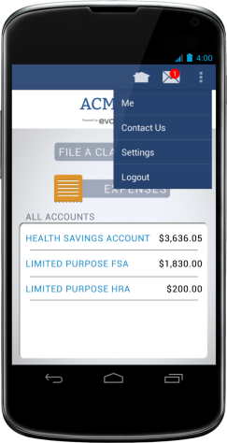
U.S. Cellular added as Text Alert Carrier
Effective, June 8, 2014

Participants can opt into text alerts through their online web account.
Simply, click on the Download Mobile App under the Message Center.

Receive text alerts about your account through your mobile phone!
You can configure which notification you would like to receive via text
message like the example below.
Standard text messaging rates may apply. Disable text alerts by unchecking the boxes.

Contact Information
* Mobile Number:
( ) -
Your mobile number will be used only for the purpose of servicing your benefit plan account. This information will not be used for any solicitations.
* Mobile Carrier:
How do I test my contact information?
* Time Zone:
Why do I need to select a time zone?

Text | Notification
Claim Confirmation
Select to receive a text message when you have successfully filed a claim for your account and a receipt may be required.
Denial
Select to receive a text message when a claim has been denied for your account to alert you a receipt or repayment may be needed.
Receipt Reminder
Select to receive a text message when a receipt reminder is created for your account to alert you a receipt is needed for a claim you have submitted.

A confirmation text message will be sent to your mobile phone upon saving your information. Sign up today!

